**RIPHAH INTERNATIONAL UNIVERSITY, ISLAMABAD**



**Lab 10**

**Bachelors of Computer science – 5th semester**

**Subject:** Operating System Lab

**Submitted to:** Ma’am Kausar Nasreen Khattak

**Submitted by: Ayiza Waqar**

**Sap Id:** 44529

**Date:** 25th October, 2024

**Lab Tasks:**

**Exercise 1:**

Put this code in a file and executes with two arguments.

echo “The following is the output of $0 script:”

echo “The total number of command line argument:$#”

echo “The first parameter:$1”

echo “The second parameter:$2”



Press i to insert

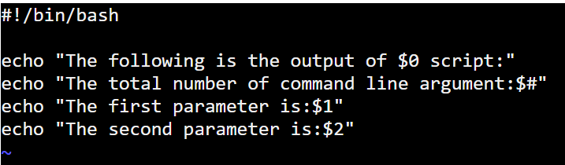

Press esc

Press Shift + : + wq

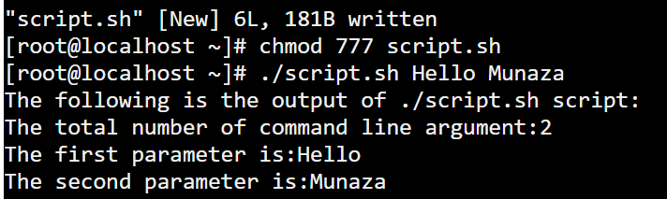

**Exercise 2:**

Write a program to take value from user between 1 to 5.and display result like this:

1. …you pressed 1
2. …you pressed 2

Above 5….invalid



Press i to insert

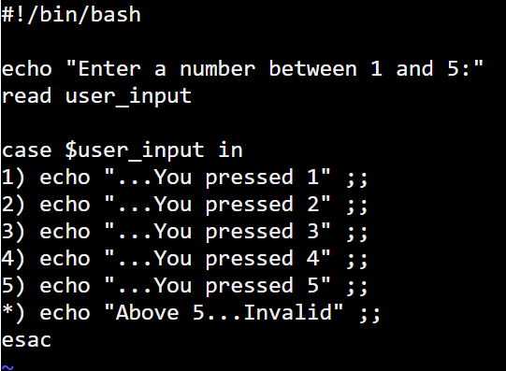

Press esc

Press Shift + : + wq

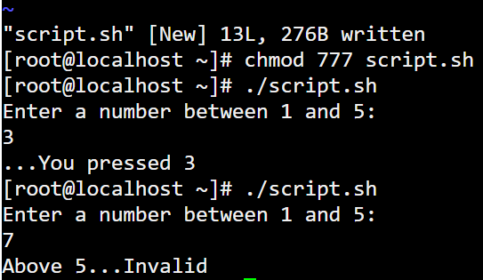

**Exercise 3:**

There are three semesters in an academic year i.e. Fall (Aug-Jan), Spring (Feb-May) and Summer (Jun-July). Write a script which read current month from the user and determine running semester. For example if user enters current month either 1 or January or Jan the script should display “Fall Semester”.



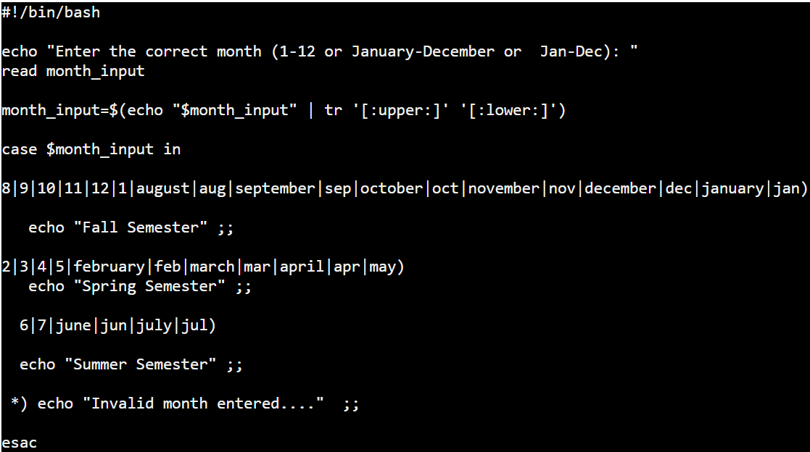

Press esc

Press Shift + : + wq

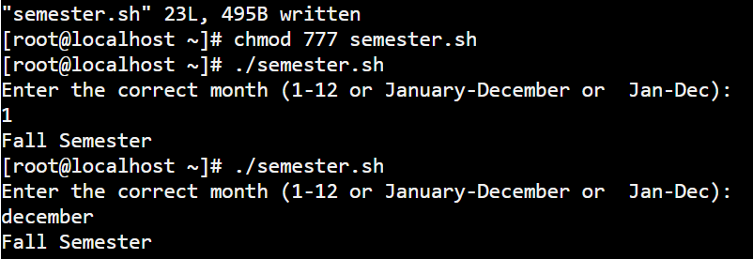

**Exercise 4:**

Write a program in shell scripting and attached screenshots with explanations

1. Perform array and string code in shell scripting

**Array:**



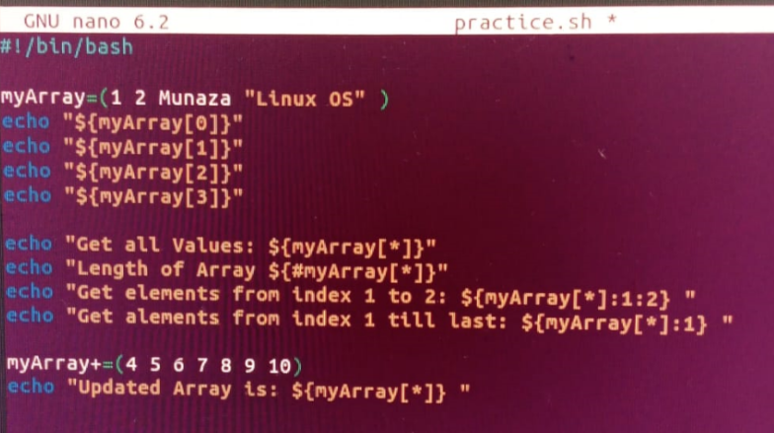

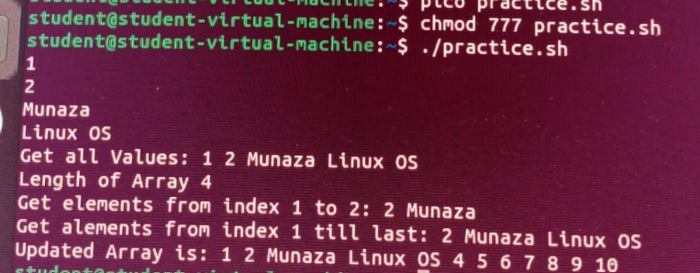

**String:**



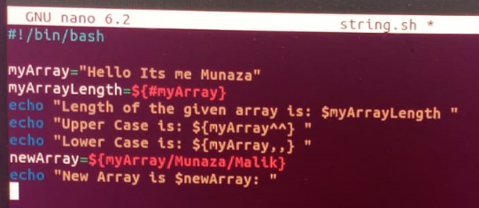

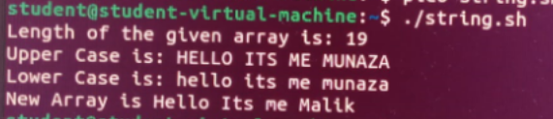

1. Perform If Else code in Shell Scripting



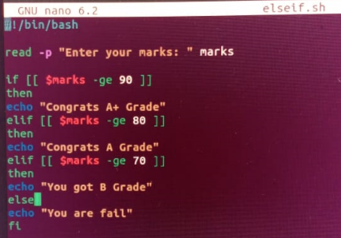

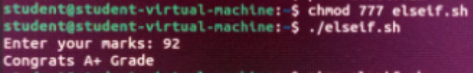

1. Perform Case related code in shell scripting



